[Four Worlds, One Country] Site Plan

[Luisa Andrein Saldarriaga Mendez]

WDD 130

Overview

Purpose
The purpose of this website is to introduce Ecuador and highlight its unique geographic diversity. Ecuador is a country where visitors can experience four different regions: the Pacific Coast, the Andes Mountains, the Amazon rainforest, and the Galápagos Islands. The website will provide information about these regions, including culture, food, natural attractions, and travel tips. It will also include personal stories and experiences shared by travelers and local people to give visitors a more authentic understanding of Ecuador and its culture.

Audience
The target audience includes travelers, students, and those interested in learning about Ecuador and South American cultures. The website is designed for people who may not know much about Ecuador and want a simple, engaging way to explore the country and its regions.

Branding

Website Logo

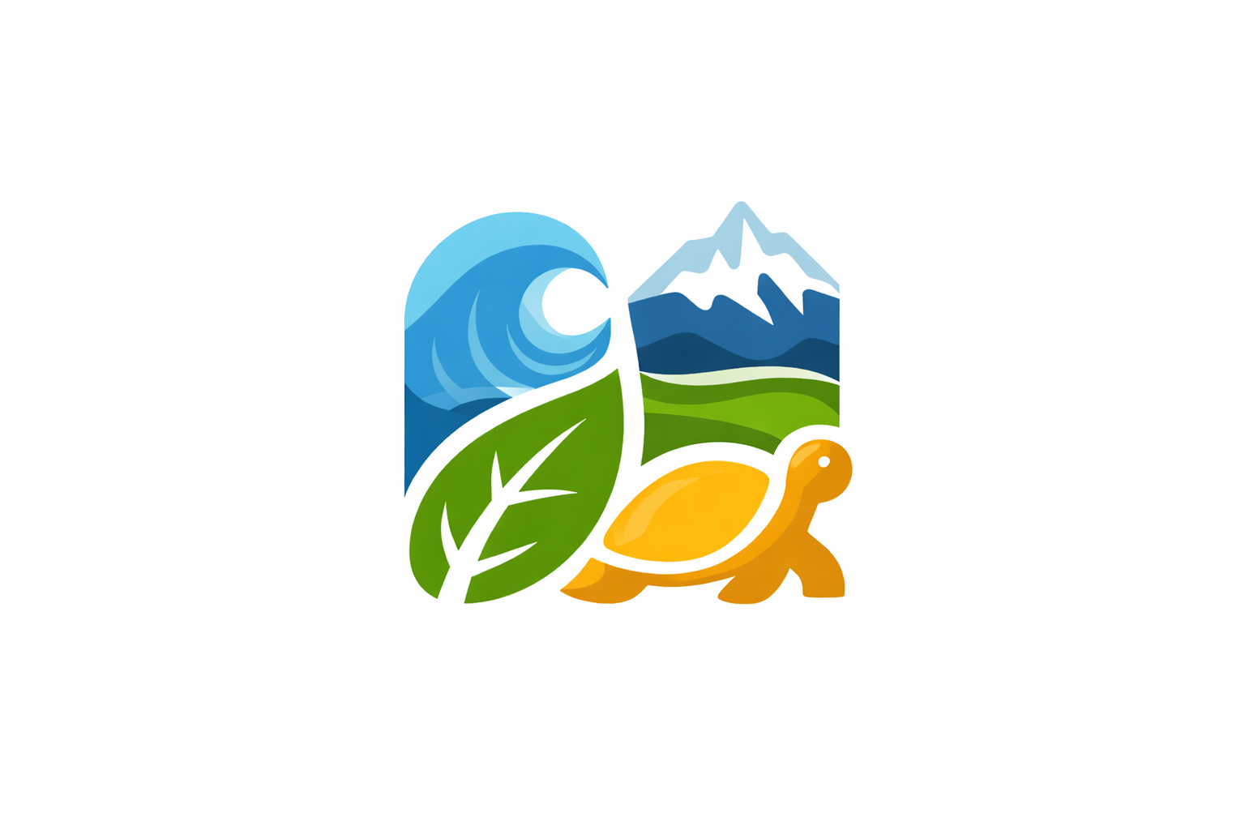
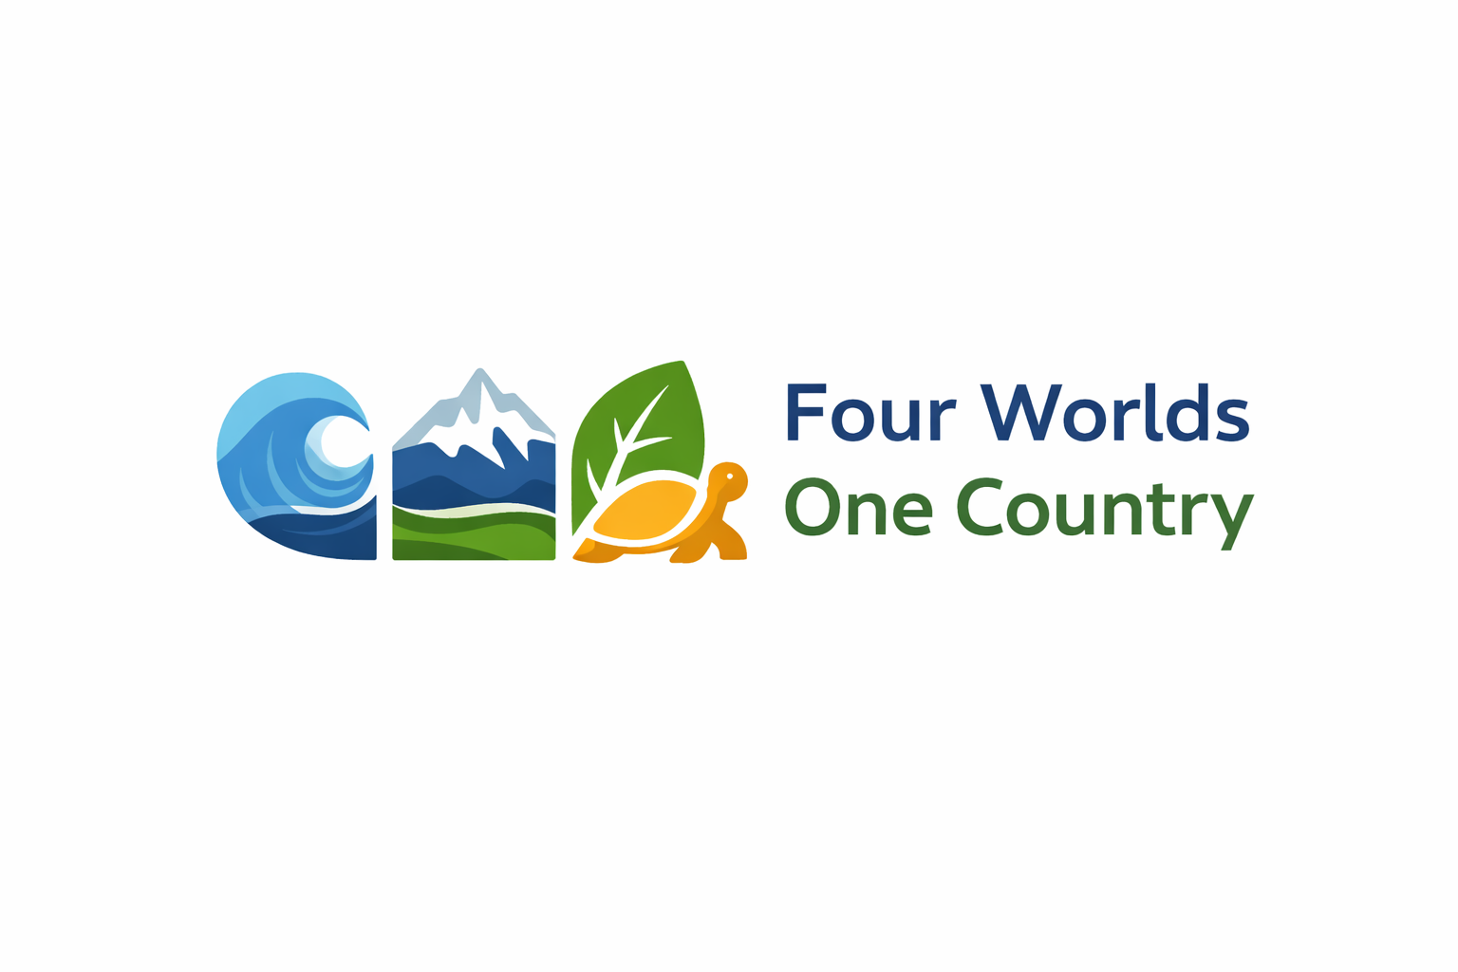

Style Guide

Color Palette
Primary | Secondary | Accent 1 | Accent 2 | Accent 3
#FFFFFF | #0D3B66 | #3A6EA5 | #2E7D32 | #D9A441

Typography

Heading Font: Montserrat

Paragraph Font: Open Sans

Navigation
Home Page2 Page3

Content

Home Page

Title
Four Worlds, One Country: Discover Ecuador

Introduction
Ecuador is a small country located in South America, but it offers an incredible diversity of landscapes and cultures. In one country, visitors can explore four completely different regions: the Pacific Coast, the Andes Mountains, the Amazon rainforest, and the Galápagos Islands.

Main Sections
- Introduction to Ecuador
- Overview of the four regions
- Short description of each region
- Images representing each region
- Invitation to explore more about Ecuador

Images
- Beach from the Pacific Coast
- Andes mountains landscape
- Amazon rainforest river
- Galápagos turtle

Regions Page

Title
Explore Ecuador’s Four Regions
This page explains each region of Ecuador.

Coast
Beautiful beaches, seafood, and coastal culture.

Andes
High mountains, volcanoes, and historic cities like Quito.

Amazon
Dense rainforest with incredible biodiversity and indigenous cultures.

Galápagos Islands
Unique wildlife and one of the most famous natural reserves in the world.

Images
- Coast beaches
- Andes volcanoes
- Amazon rainforest
- Galápagos animals

Experiences Page

Title
Experiences in Ecuador
This page will include stories and experiences from travelers and local people.

Sections
- Traveler stories
- Local culture and traditions
- Typical food from Ecuador
- Travel tips for visitors

Example Experience
“Visiting the Amazon rainforest in Ecuador was an unforgettable experience. The wildlife, the rivers, and the connection with nature made it one of the most amazing trips of my life.”

Wireframes

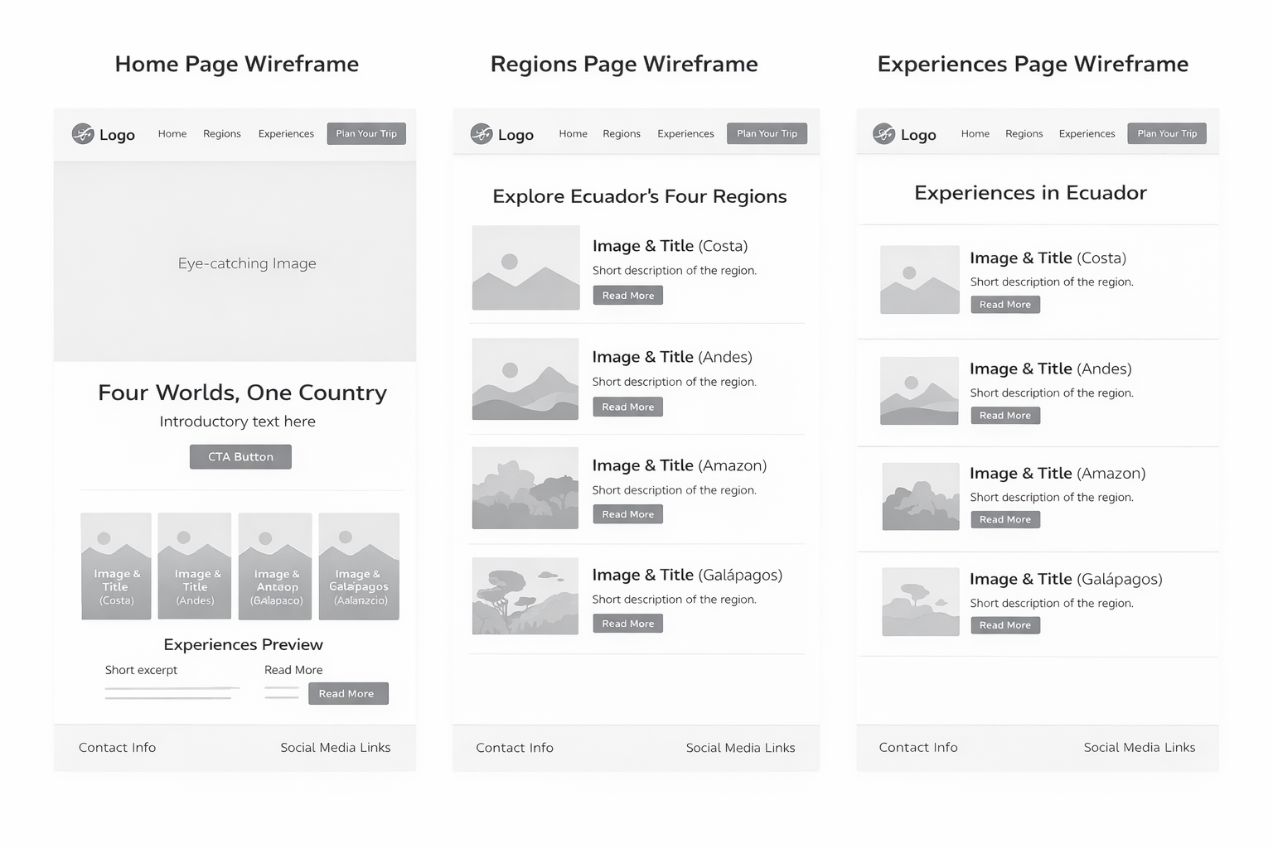
Home

